**Fractional-Order Darwinian Swarm Intelligence Inspired Multilevel Thresholding for Mammogram Segmentation**

Santhos Kumar A., A. Kumar, V. Bajaj and G. K. Singh

Abstract—**Multilevel thresholding** is more accurate than the classical thresholding method for segmenting a digital mammogram, since **it uses more number of intensities** to represent the objects. It is intuitively appreciable for further detection of breast cancer using such kind of clinical database.**The main goal of any multilevel thresholding based segmentation is to optimize its objective function to obtain different threshold levels; but multilevel thresholding is computationally expensive, and sometimes these optimized values are not accurate.** Therefore, in this paper, **an amalgamation of n-level thresholding and fractional-order Darwinian particle swarm optimization (FODPSO) is studied in detail, and was found to be the best among various PSO variants based thresholding for efficient mammogram image segmentation**. The efficiency of the proposed technique is compared with other segmentation technique, based on thresholding such as **particle swarm optimization (PSO)** and **Darwinian particle swarm optimization (DPSO)**. Individual performances of hereby employed algorithms are compared and analysed using the performance measures such as **PSNR, SNR, SSIM, and MSE.**

**Dataset**

**DDSM database**

**Mammogram Image Analysis Society (MIAS) database**

To analyse mammograms efficiently in many areas, **segmentation of pectoral muscle is useful.** Pectoral Muscle limits the search area for suspicious region in the digital mammographic image. To detect the pectoral muscle, a popular **Hough transform technique** is used in Gradient magnitude ridge traversal technique is used at small scale. In, authors have identified the breast boundary in mammograms using **contour model**,

and **finally resulted into pectoral muscle, fibro-glandular tissue and skin-air boundary.** Dynamic programming technique is used to refine the Hough transform. To extract the pectoral muscle from mammogram image, Georgsson used **region growing technique.**  **Particle Swarm Optimization (PSO)** is one of the most popular and robust technique. In search of improved model of natural selection, formulated the **Darwinian Particle Swarm Optimization (DPSO) in 2005 on the basis of PSO technique.** In this paper, **PSO algorithm and its two variants such as DPSO and FODPSO are proposed for segmentation of breast, pectoral muscle and suspicious mass from mammographic image.** The proposed FODPSO method gives the best **threshold values among other two techniques such as PSO and DPSO to segment mammogram image efficiently.**

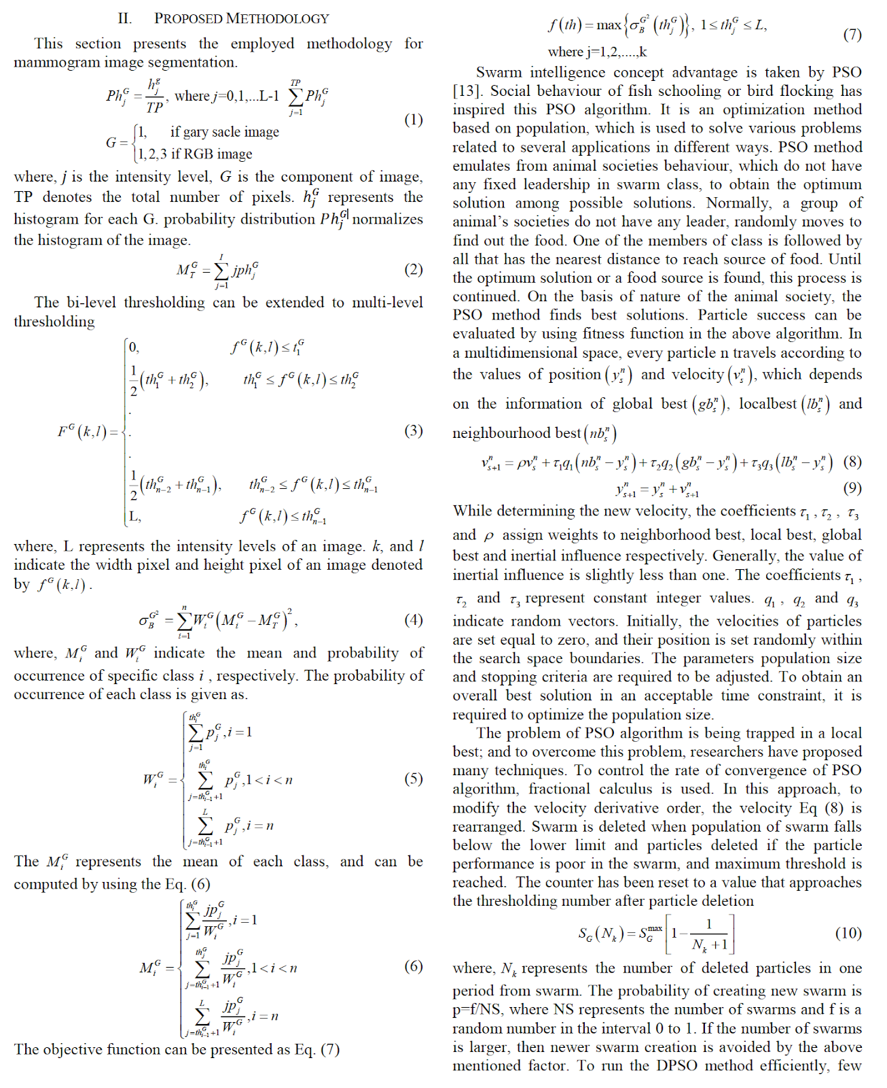

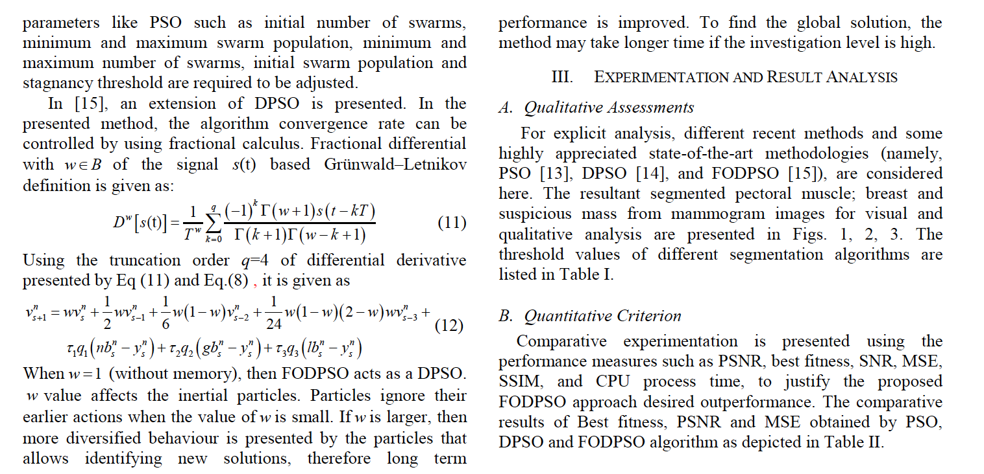

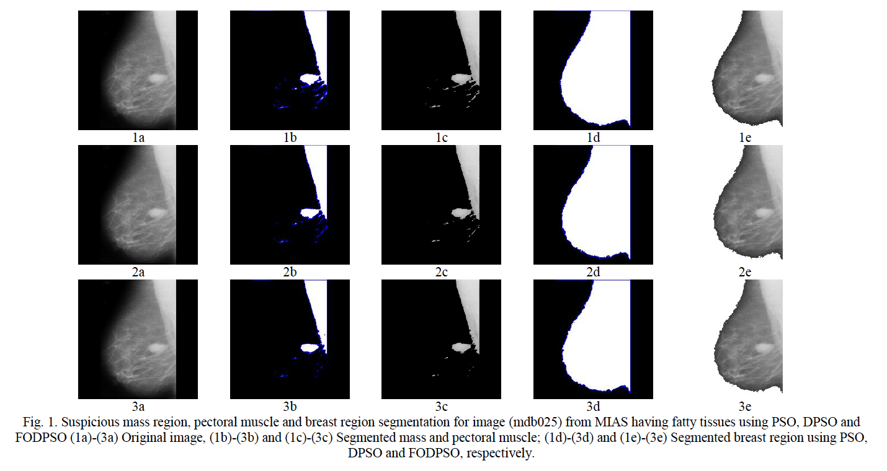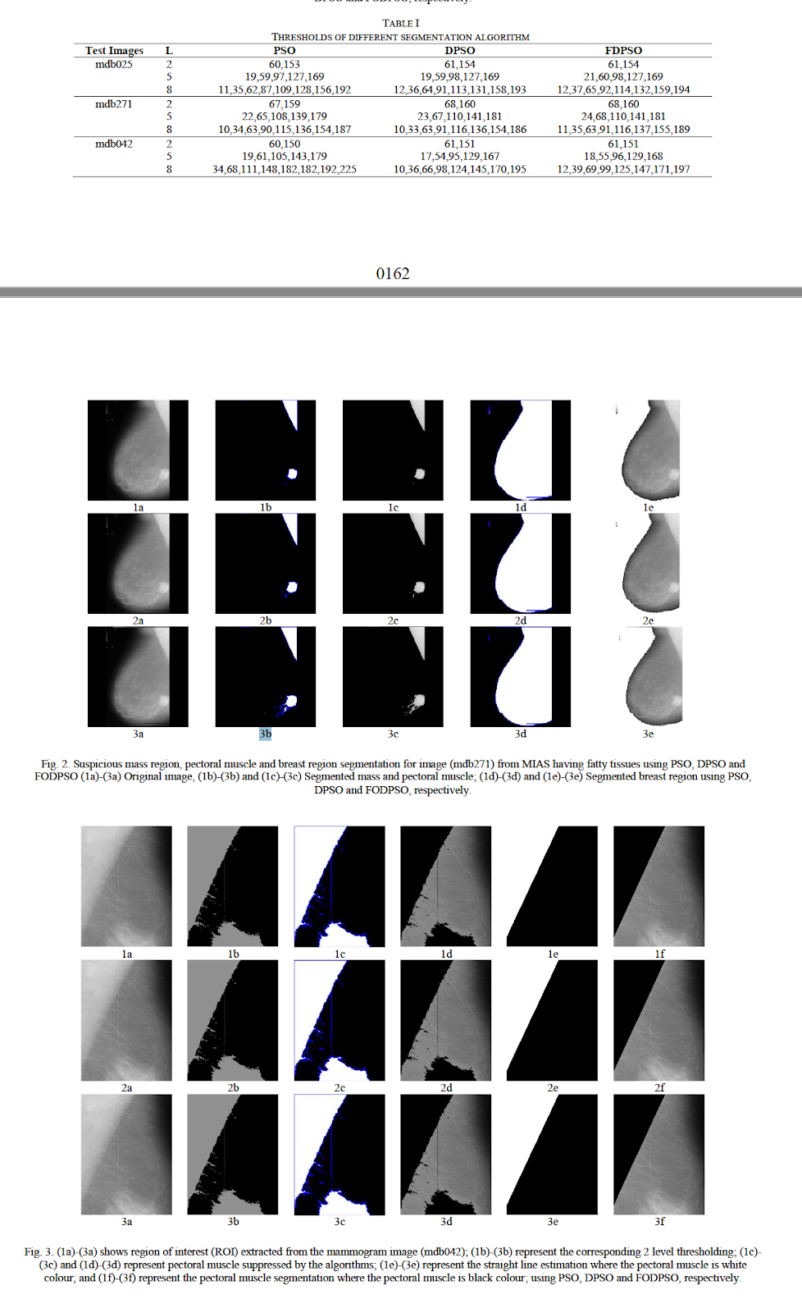

In this work, **fractional-order Darwinian particle swarm optimization  (FODPSO) is employed and suggested to segment the pectoral muscle, breast and suspicious mass, efficiently.** In order to obtain **the optimal threshold values, the objective function of multilevel thresholding method, Otsu’s cost function is given as input to FODPSO, DPSO and**

**PSO.** The proposed technique is applied to all the images in MIAS database successfully. The performance of PSO, DPSO and FODPSO are compared successfully by using the performance metrics such as PSNR, SNR, SSIM, best fitness value and MSE. It is concluded that the **efficiency of FODPSO is superior to DPSO and PSO.** When segmentation levels increases, FODPSO becomes more efficient than the other two segmentation techniques. Some new optimization techniques can be applied to segment the bio-medical images in future, and much better results can be anticipated